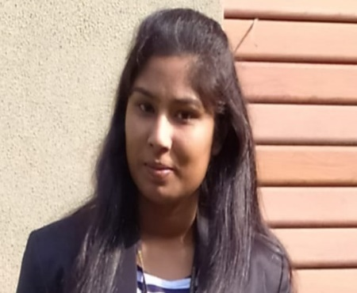

Anamika Kumari

Phone No._ 7024474040, 6380201641
E-mail:anamikaok2@gmail.com Skype ID:-7024474040
Passport no. R6538044

Career Objective:
To utilize my knowledge and skills in the area of physical education and fitness, for the development of physical education, games and sports and enhance the career revenue. Also want to attempt a challenging job to prove myself and want to become a unique example in the field (job) of Physical Education and Sports.

PROFESSIONAL QUALIFICATION

Course | University | Year | percentage
M.P.ED | Lucknow University | 2020 | 83%
B.P.Ed | LNIPE, Gwalior | 2017 | 71 %

ACADEMIC QUALIFICATION

Course | Board/College/ University | Year | Percentage
Intermediate | BSEB Bihar Board | 2013 | 70 %
High School | BSEB Bihar Board | 2011 | 75 %

WORK EXPERIENCE
- Currently working in THE GAUDIUM SCHOOL as a PYP PE Teacher (IB SCHOOL).
- Worked in Good Shepherd International School, Ooty.
- Completed Internship Program of 45 days in INDIAN HERITAGE SCHOOL, PATHANKOT
- Conducted an Off Campus Training Program on Mass Display at KIDDY’S CORNER,
GWALIOR .

GAME SPECIALIZATION: BASKETBALL

SPORTS ACHIEVEMENT

  - 65th Senior M.P. State Basketball Championship, 2014-15 1 place.
  - 66th senior M.P. State Basketball Championship, 2015-16 1 Place.
  - 18th Youth Volleyball State Championship, 2015-16 from LNIPE 1 Place.
  - Squash all India Inter University Participate in 2016-17 From LNIPE.
  - Basketball Inter University Participated 2014-15 LNIPE.

OTHER EXPERIENCE
- Participated in LEADERSHIP TRAINING camp held at the PACHMARHI 2015.
- Participated in National Workshop on “Basic Life Saving Skills For Life Threatening Situation”

OTHER GAMES AND SPORTS CONFIDENCE OF HANDLING
Volleyball, Badminton, Mass Demonstration, Yoga, Multi Gym Organization, Adventure Sports, Aerobics, Recreational Activities, Cricket, Kho-Kho, Kabaddi, Badminton, Football, Tennis, Table Tennis, Handball, Judo, etc

.

PERSONAL PROFILE
Father’s Name : Sh. ASHOK KUMAR Mother’s Name : Smt. KANCHAN DEVI Date of Birth : 07/02/1997
Gender : Female
Marital Status : Unmarried
Nationality : Indian Language Known : English/ Hindi

COMPUTER LITERACY:
- Good Knowledge of Computer, Microsoft word, Power point, excel & making attractive presentation etc.
- Good Knowledge of internet, Overhead projector etc.
- Experience of conducting online classes.

REFERENCE
- Prof. Wilfred Vaz. Co-ordinator, Placement Cell L.N.I.P.E., Gwalior

Mob. +91-9425338952

  - Asst Prof. Birender Jhajhariya
Dept. of Physiology
L.N.I.P.E. Gwalior

Mob. +91-9301888411

DECLARATION
I hereby declare that the information provided above is true to the best of my knowledge and belief.

Date:30/01/2021

(Anamika Kumari)

