  LOKESH KUMAR SATNAMI
  Date of birth : 11.05.1989
  Contact
  Mobile : +91-8770481071
  E-mail : lsatnami89@gmail.com
Address

LokeshKumarSatnami
AT –Ward No-14, PO-Khariar Road
Dist-Nuapada(Orissa)
Pin-766104
Objective
To work in an innovative and competitive environment where I can apply my knowledge and thought as well as constantly learn and contribute to the growth of the organization. My learning ability, commitment and hard work are the strengths that will help me in becoming a successful professional.

Education
Year | Course | Institution/College | YOP | %/CGPA
2008-2012 | B.TECH | BPUT University | 2012 | 61%/6.60
2006-2008 | 12th SCIENCE | JawaharNavodayaVidyalaya,Nuapada | 2008 | 64%
2006 | 10th | JawaharNavodayaVidyalaya,Nuapada | 2006 | 76.2%

2017-  2019 | D.el.ed | NIOS, New Delhi | 2019 | 62.00%

Personal Strength
- Competitiveness and.
- Teamwork as well as leadership quality.
- Self-confidence helps to adapt most of the conditions and any circumstances.
- Optimistic, realistic thinking and Positive attitude.
- Good communication skills especially in English

Computer Efficiency
- Computer Fundamentals
- M S Office
- Programming Logic & Technique
- Programming in ‘C’ & C++
- Software Management & Algorithms
- Java
- MS-SQL
- Database management
- Internet

Work Experience
Employer | Designation | Duration | Responsibilities
PARIVARTAN Chhattisgarh | Program Coordinator | One Year  (2012) | Responsible for following works  - Various Reports writing  - System Administration  - Handling Computer literacy program  - Fact finding and documentation  - Organizing program and events  - Conducting monitoring and evaluation
St. John’s English Med. Hr. Sec. School, Chhura, Gariyaband, CG | Teacher Cum Academic & Session Coordinator | 16 June 2013- 7th May 2020  ( 8 Year) | Responsible to deal with following subjects and area  - Academic and Session Coordinator  - Science-VI-X  - Mathematics- V & VIII  - Liasoning and mobilization of parents  for increase of students.
Handicraft Emporia, Nuapada | Marketing Cum Sales Representative | April 2020- Till Now | Responsible to deal with  - Sales promotion at various outlets  - Marketing and promotional activities in different District and State level Exhibition.  - Shop to shop product display and marketing.

Declaration
I hereby declare that the above-mentioned information is correct up to my knowledge and I bear the responsibility for the correctness of the above mentioned particulars.

PLACE :- Kh. Road 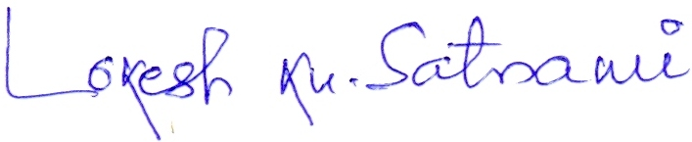 DATE :- 01.02.2021 Signature

