ADDRESS FOR CORRESPONDENCE : MOBILE : 8961055242 , 9123074673

47,Chittaranjan Das Sarani ( Near EMAIL: rumpaduttavis@gmail.com
Regent Boy’s Club),
P.O.-Ghoshpara; P.S.-Nischinda;
Bally , DISTRICT-Howrah,
STATE- West Bengal; PIN-711227
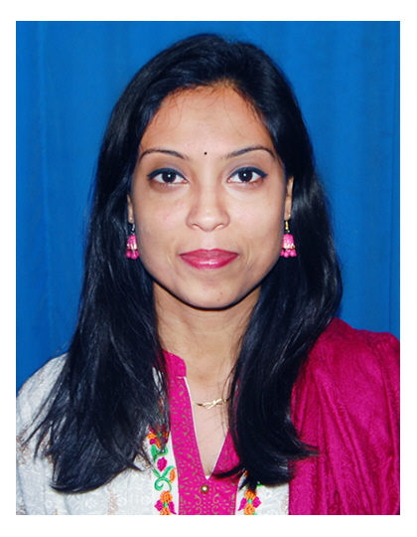

Resume of Rumpa Dutta
Educational Qualification | Year course Name of Institute Subjects Board Percentage  2010 B.A Hiralal majumdar English Calcutta  University 40%  memorial college  for women  (Dakhineshwar)  2007 12th Little Star High School Commerce I.S.C 61%  2005 10th Little Star High School Commerce I.C.S.E 54%
Professional Qualification | 2008 - Diploma In Information Technology YOUTH (Howrah) 82%  2017 - Teachers Training Course(TTC) N.C.V.T.E 60%  2020 - D.EL.ED Kuntala Das College of Education(WBBPE ) Yet to come
I am an well-organised and qualified primary teacher with a number of years teaching experience behind me.I am an ambitious and confident person ,a quick learner and keen to work in any situation, and can prove myself as a best choice for any employer.All I can define myself in one sentence is : I teach therefore I learn.

WORK EXPERIENCE :
Primary School Teacher-Academy Centre (Asst.Teacher),-April,2011 –November,2014
- Liaised with the headteacher to organise a new procedure of teaching for a holistic development.
- Organised several school cultural programs for the pre primary and middle school.
- Woked on a self made well planned worksheets for the children.

Primary School Teacher-Eurokids International School (Asst.Teacher),-December,2014 – November,2015.
- Played an important role in planning out the learning goals for a specific instructional period to preparing the children for the next levels.
- Provided structural help to the children to grow in their reading and writing skills using phonetics, taught social science and help children understand themselves.
- Worked on the whole child development – physical, social, emotional, and cognitive development.
Primary School Teacher- Vission International School (Asst. Teacher),-April,2016-March,2019.
- Taught the children Phonics to decode letters into their respective sounds to read unfamiliar words by themselves.
- Retrained with several Phonetics and Phonology workshops to enable them to teach PHONETICALLY.
- Developed a monitoring programme to assist newer member of the teaching staff overcoming professional difficulties.
- Careful Lesson plan planner with the skill to keep all record presentable and up-to-date.
- Efficiently managed a class of 47 children for covering over all development.

KEY SKILLS
- Good verbal communication .
- Proficient in PHONETICS.
- Can easily adapt with the new curriculum of the any given board.

CAREER OBJECTIVES

Dedicated academic professional committed to providing comprehensive instruction that frostier child development. Highly skilled in managing class environment. Demonstration capacity to teach, motivate and direct students while maintaining high level interests and achievements.Skilled in E-Learing,Classroom Management,Lesson Planning and Educational Technology.Superb interpersonal skill, able to establish positive relationship with students parents and faculty members. Strong planning organising and leadership abilities.

PERSONAL DETAILS:
Father’s Name : Late Tapan Dutta
Date Of Birth :16.03.1989
Sex :Female
Marital Status :Single
Nationality :Indian
Language Known : English ,Bengali, Hindi (Read, Write and Speak)
INTEREST :
Dancing, Painting, Environment,Art & Culture and Learning different languages.
ACHIEVEMENTS :
Won 1st prize position inter School Dance Competition for two consecutive year conducted by Pearls of God school .
DECLARATION:
I, hereby solemnly declare that all the statements made above are true and correct to the best of my knowledge and belief.

Place :
Date :
..........................................................
Signature

