RESUME
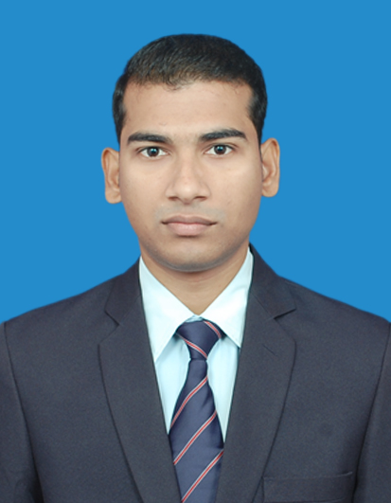

Sushanta kumar pattnaik
S/o-Nakula charan pattnaik
At-Professors’ colony
Po-Budharaja
Dist-Sambalpur
Pin-768004
Phone-08249417397
Email id-sushantakumarpattnaik@gmail.com

CAREER OBJECTIVE:-
To be a part of a branded organization where I can contribute my knowledge, hone skills and learn new ideas for development.

EDUCATIONAL DETAILS:-
Professional Qualification:
- Completed B.Ed in English and Social Studies from Kurukshetra University, 2012.
Educational Qualification:
- M.A in Economics from Bharathiar university,Coimbatore,2019
- B.A in Economics (Hons.) from Gangadhar Meher Autonomous College, Sambalpur, 2011.
- Intermediate (Arts) from Gangadhar Meher Junior College, Sambalpur in 2008.
- Matriculation from Chandrasekhar Behera Zilla School, Sambalpur in 2006.

TECHNICAL KNOWLEDGE:-
- MS-Window, XP and MS-Office 2003, 2007, 2010
- DCA From OCML, Sambalpur

PROFESSIONAL STRENGTH:-
- Good at communication(Hindi,English,Odia)
- Self development with positive attitude.
Work Experience:
- Working as a TGT Social Science in Academic World School, Bemetara. (Residential school)
(Affiliated to CBSE, New Delhi) chattishgarh.
From 19th July 2018 - continuing.
Grade:-7th , 8th & 9th (Social Science)
Role:
Subject Head
Class Teacher
Conduct, Science Olympiad Foundation examinations.
House Master
- Working as a TGT Social Science in DPS Champa (Affiliated to CBSE, New Delhi) Chhattisgarh.
From 8th Jan 2018 to 13th June 2018.
Taking 9th & 10th classes (Social Studies) 11th & 12th (Economics)
Role:
Class Teacher
- Working as a TGT Social Science in Kerala English Medium School, Champua (Residential school)
(Affiliated to CBSE, New Delhi) Champua, Keonjhar.
From 20th June 2015 to 24th Dec 2017.
Taking 9th & 10th classes (Social Studies) 11th & 12th (Economics)
Role:
Class Teacher
House Master
Exam Cell Assistant In charge

- 2 years of experience in teaching of Economics (+2 level), in different private educational institutions of sambalpur.
Online teaching link: https://www.youtube.com/watch?v=vJRErw-Obz0&t=1299s
https://www.youtube.com/watch?v=J2Y-kaLm6dQ&t=14s
https://www.youtube.com/watch?v=wyvfqWcGJI8&t=541s
Other Achievements:
- NCC “B” Certificate from 5(O) Batalion,Sambalpur
- National Integration Camp, Ranchi
- Special National Integration Camp, Kakinada, AP
- Cultural secretary of G.M (Auto) College,Sambalpur 2011

PERSONAL INTEREST:-
- Writing poetry in Hindi, English & Odia.
- Kite flying.
PERSONAL DETAILS:-
Date of Birth : 5th May 1990
Marital Status : Married
Religion : Hindu
Category : General
Nationality : Indian
DECLARATION:-
I hereby certify that all statements made and information given by me in this resume are true and correct to the best of my knowledge and belief.

Place: - sambalpur Sushanta Kumar Pattnaik
Date:-

